**Experiment- 5,6**

**Title:** Use of Inbuilt functions and relational algebra operation

**Objective:** To understand the use of inbuilt function and relational algebra with sql query.

1. Consider the following table structure and attempt.

Supplier-(scode,sname,scity,turnover)

Part-(pcode,weigh,color,cost,sellingprice)

Supplier_Part-(scode,pcode,qty)

1. Create tables

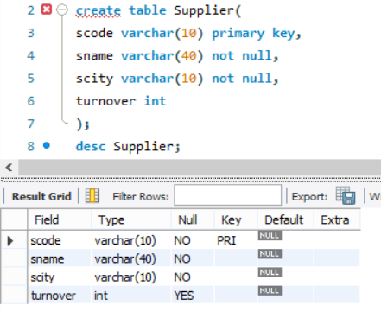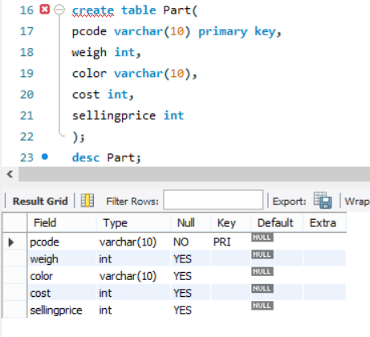

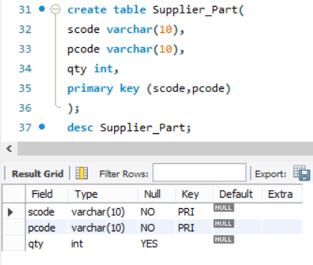

1. Populate the table.

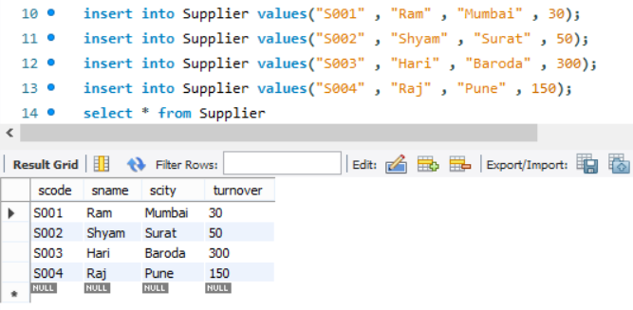

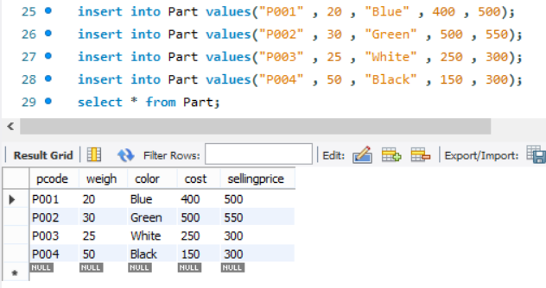

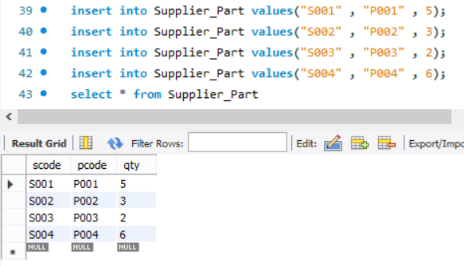

2. Write appropriate SQL Statement for the following:

1. Get the supplier number and part number in ascending order of supplier number.

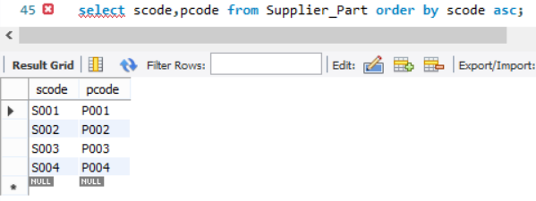

1. Get the details of supplier who operate from Mumbai with turnover 30.

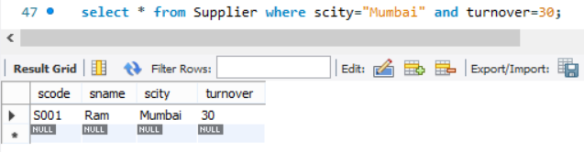

1. Get the total number of supplier.

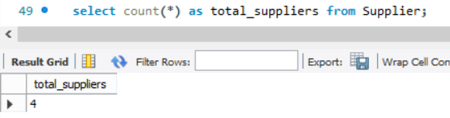

1. Get the part number weighing between 25 and 35.

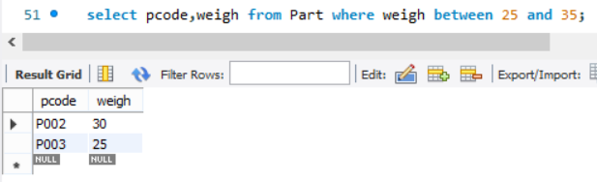

1. Get the supplier number whose turnover is null.

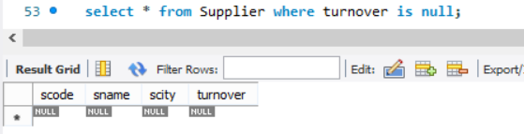

1. Get the part number that cost 20, 30 or 40 rupees.

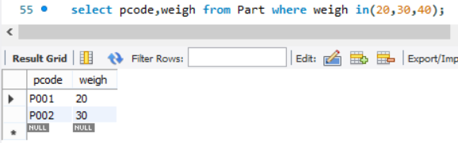

1. Get the total quantity of part 2 that is supplied.

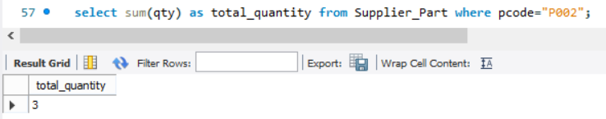

1. Get the name of supplier who supply part 2.

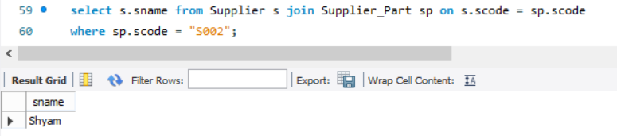

1. Get the part number whose cost is greater than the average cost.

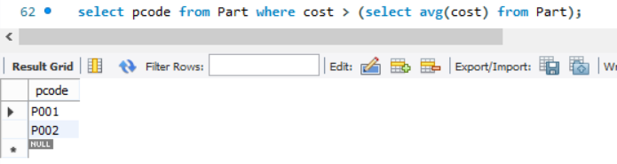

1. Get the supplier number and turnover in descending order of turnover.

